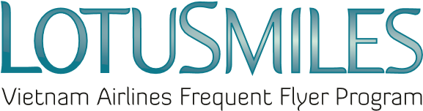

AWARD REDEMPTION REQUEST
(PRODUCT & SERVICE OF LOTUSMILES NON-AIR PARTNERS)
- Present this Award redemption request and all required documents at any Vietnam Airlines branch offices worldwide.
- Check your Lotusmiles account to ensure you have enough miles to redeem the award.
Member’s full name:
Email: Tel:
Lotusmiles membership number:
Issuing ticket offices:
Note: Email and telephone number are mandatory information

☐ MOBIFONE AWARD REQUEST
Beneficiary name | Package  (200.000 VND; 500.000 VND; 1.000.000 VND) | Mobifone number

☐ VINID AWARD REQUEST
Beneficiary name | VINID points  (Minimum 500 points/transaction) | VINID card number

☐ ACCOR PLUS AWARD REQUEST
Beneficiary name | Information to receive Accor Plus Card  (Mobile phone number, post address)

Required documents when requesting Lotusmiles award at Vietnam Airlines branch offices:  - Award Redemption Request  - Identify card or Passport (Original) and the information of the award beneficiary (Identify or passport number, DOB)  - Lotusmiles membership card  - Authorized paper (If needed) | ☒ I agree with Lotusmiles award terms, conditions and the Privacy Policy of Vietnam Airlines  Member’s signature  Date: / /

