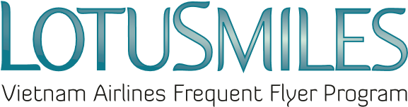

AWARD REDEMPTION REQUEST
(TICKET, UPGRADE, EXTRA BAGGAGE)
- Present this Award redemption request and all required documents at any Vietnam Airlines branch offices worldwide
- Check your Lotusmiles account to ensure you have enough miles to redeem the award, then contact our Call center to make a confirmed booking for award ticket.
Member’s full name:
Email: Tel:
Lotusmiles membership number:
Issuing ticket offices:
Note: Email and telephone number are mandatory information

☐ AWARD TICKET REDEMPTION
Booking code | Itinerary | Flight number | Flight date | Class of service | Passenger name

☐ UPGRADE AWARD REDEMPTION
Booking code | Itinerary | Flight number | Flight date | Class of service to upgrade | Passenger name

☐ EXTRA BAGGAGE REDEMPTION
Booking code | Itinerary | Flight number | Flight date | Baggage package  (10kg/20kg/30kg) | Passenger name

Required documents when requesting Lotusmiles award at Vietnam Airlines branch offices:  - Award Redemption Request  - Identify card or Passport (Original) and the information of the award beneficiary (Identify or passport number, DOB)  - Lotusmiles membership card  - Authorized paper (If needed) | ☒ I agree with Lotusmiles award terms, conditions and the Privacy Policy of Vietnam Airlines  Member’s signature  Date: / /

