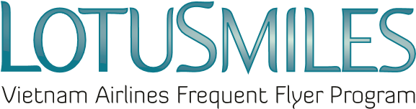

AUTHORIZATION PAPER

I, the undersigned, hereby authorized Ms/Mr:………………………..with the following information:
- Full name:
- Identity/passport number:
- Phone number:
- Email:
to act on my behalf in all possible manners to my Lotusmiles account, including:
☐ Request to be provided my account activities
☐ Redeem my miles
☐ Claim my missing miles
☐ Buy/transferring my miles
This authorization is valid from:…………………………..to:……………………………………………

Required documents when authorizing:  - Scan copy of Lotusmiles membership card  - Scan copy of member’s identity card/passport  - Scan copy of Authorized person’s identity card/passport  - In case the authorized person request the award at Vietnam Airlines branch offices, he/she is required to present the original copies of all documents above. | ☒ I agree the Privacy Policy of Vietnam Airlines  Member’s signature  Date: / /
=========================================================================
Note: Each member can assign to only 01 person in a certain period.

