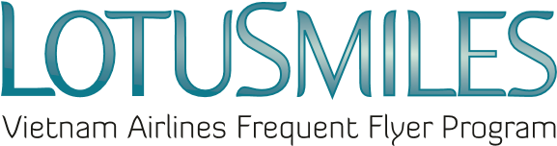

會員帳戶管理授權委託書(請以英文大寫字母填寫)
AUTHORIZATION PAPER

I, the undersigned, hereby authorized Ms/Mr:………………………..with the following information:
立書人特此授權下列受託人:
- Full name受託人姓名:
- Identity/passport number證件/護照號碼:
- Phone number聯絡電話:
- Email信箱:
to act on my behalf in all possible manners to my Lotusmiles account, including:
代為管理本人會員帳戶相關事宜，項目如下:
☐ Request to be provided my account activities 帳戶資訊查詢
☐ Redeem my miles 哩程兌換
☐ Claim my missing miles 哩程補登
☐ Buy/transferring my miles 哩程購買與轉讓
This authorization is valid from:…………………………..to:……………………………………………
此授權有效期限:

Required documents when authorizing  授權申請應備文件:  - Scan copy of Lotusmiles membership card會員卡影本  - Scan copy of member’s identity card/passport 會員身分證/護照影本  - Scan copy of Authorized person’s identity card/passport 受託人身分證/護照影本  - In case the authorized person request the award at Vietnam Airlines branch offices, he/she is required to present the original copies of all documents above. 受託人亦需備齊上述所有文件以利後續申請獎勵兌換事宜 | ☒ I agree the Privacy Policy of Vietnam Airlines  我已詳閱並同意越南航空隱私政策  Member’s signature 會員簽名  Date日期: / /
=========================================================================
Note: Each member can assign to only 01 person in a certain period
每位會員僅能於指定期間內授權一位受託人代為管理其帳戶.

