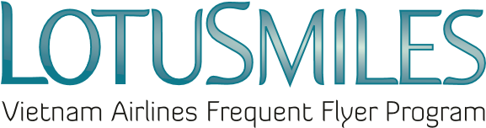
獎勵哩程轉讓申請表(請以英文大寫字母填寫)
TRANSFERRING MILES REQUEST
TRANSFEROR’S FULL NAME 轉讓人
Transferor’s Full Name轉讓人全名:
Email信箱: Mobile phone手機:
Membership No.會員號碼
Attention: Email address and Telephone number are mandatory information

TRANSFEREE’S FULL NAME 受讓人
Transferee’s Full Name受讓人全名:
Email信箱: Mobile phone手機:
Membership No. 會員號碼

Transfering mile request 哩程轉讓申請
Amount of transferred miles轉讓哩程數:
Condition條款與規範
- Transferred miles are non-refundable and not used for qualifying tier level. 哩程一經轉讓將無法退還，且不適用於會員升等。
- If transaction is conducted outside Vietnam, rate per mile is US$ 0,01.於越南以外國家轉讓之費用:0.01美金/每哩程。
- If transaction is conducted within Vietnam, rate is VND 235/mile.於越南當地轉讓之費用:235越盾/每哩程。
- Rate is included all taxes and fees relating to the transaction.費用皆含稅。
- Transferred miles are rounded as increment of 1.000.轉讓哩程以1,000哩為單位出售。
- Price and conditions may be changed at any time with (or without) prior notice. 價格規範如有異動恕不另行通知。
Please process my transaction at the Vietnam Airlines office indicated herein:本人同意越南航空經手此筆交易:
Date日 Month月 Year年 Transferor’s signature轉讓人親簽 Transferee’s signature受讓人親簽

