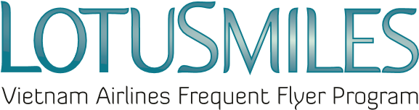

CONVERT BONUS MILES REQUEST
MEMBER’S FULL NAME
Email: _____________________________________Telephone: __________________________________
Membership No.: _______________________________________________________________________
(Attention: Email address and Telephone number are mandatory information)

Request to convert …………………………………………….bonus miles to:

☐ ………………………qualifying miles ☐ ……………… qualifying segments

CONDITIONS:
- The conversion rate is: 15,000 bonus miles = 1,000 qualifying miles or 01 qualifying segment.
- If the transaction is conducted outside Vietnam, the processing fee is US$ 10 per transaction (includes all taxes and fees)
- If the transaction is conducted within Vietnam, the processing fee is VND 235.000 per transaction (includes all taxes and fees)
- Converted qualifying miles can be used for award redemption per Lotusmiles policies
- Price and conditions may be changed at any time without prior notice

Process transaction at Vietnam Airlines office: …………………………………………………………

☒ I agree with Lotusmiles terms and conditions and the Privacy Policy of Vietnam Airlines

Member’s signature

Date: / /

