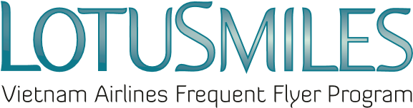

LOTUSMILES PURCHASE REQUEST FOR BONUS MILES FORM

Buyer’s full name: ___________________________________________________________________________________
Email: _________________________________________ Telephone: __________________________________________
Mile receivers’ membership No.: ____________________________________________________________________
Mile receivers’ full name: ____________________________________________________________________________
(Email address and telephone number are mandatory information)

Purchase amount of bonus miles: ______________________________
CONDITIONS:
- Purchased bonus miles are not used for qualifying tier level
- Purchased bonus miles are non-refundable
- Rates are VND 575/mile for transactions conducted within Vietnam and USD 0.025/mile for transactions outside Vietnam
- Rate includes all transaction taxes and fees
- Bonus miles can be purchased in units of 1,000 miles
- Price and conditions may be changed at any time without prior notice
Pay at Vietnam Airlines office: ______________________________
I agree with the above conditions:

_____ _______ ______ ______________________________
Date Month Year Buyer/Member’s signature

