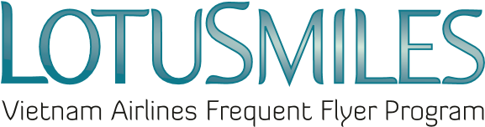
獎勵哩程購買申請表(請以英文大寫字母填寫)
LOTUSMILES PURCHASING BONUS MILE REQUEST
Buyer’s Full Name購買人全名:……………………………………………………………………………….
Email信箱:……………………………………………..Mobile phone手機:………………………………
Mile receiver’s membership No. 哩程入帳會員號碼………………………………………………………..
Mile receiver’s full name 哩程入帳會員全名………………………………………………………….……..
(Email address and Telephone number are mandatory information) 信箱及連絡電話為必填項目

Amount of purchasing bonus miles: 購買獎勵哩程數…………………………………………..
CONDITIONS條款與規範 :
- Purchased bonus miles are not used for qualifying tier level. 所購買之獎勵哩程將不適用於會員升等。
- Purchased bonus miles are non-refundable.哩程售出後將不予退還。
- Rates are VND 575/mile for transactions conducted within Vietnam and USD 0.025/mile for transactions outside Vietnam.於越南當地購買之費用:575越盾/每哩程;於越南以外國家購買之費用:0.025美金/每哩程。
- Rate is included all taxes and fees relating to the transaction.費用皆含稅。
- Purchased bonus miles are rounded as increment of 1.000.獎勵哩程以1,000哩為購買單位出售。
- Price and conditions may be changed at any time with (or without) prior notice. 價格規範如有異動恕不另行通知。
Pay in Vietnam Airlines Office經手分公司:
I agree with the above conditions.我已詳閱並同意上述條款。
Date日 Month月 Year年 Buyer/Member’s signature購買人/會員親簽

