USING PORTABLE INFLIGHT BED FOR CHILDREN IN FLIGHT

Travel gadgets that convert into leg rests or inflight beds for children – Portable Inflight Bed (PIB) may be used on board our flights as long as the instructions for the use are followed.
- General rules:
- Apply to children from 02 to under 12 years of age travelling on VNA operating flights.
- PIB using must adapt safety regulations.
- PIB will be counted as part of your cabin baggage allowance and comply with cabin baggage standard.
- PIB must be packed and securely stow in the overhead compartment or under the seat in front during taxi, take-off and landing.
- PIB cannot combined so as to allow two or more convertible inflight beds to occupy several seats.
- For your child’s safety, these convertible inflight beds may only be used at the window seats or the middle seat between the aisles.
- PIB cannot be used at the emergency exit rows.
- PIB must not interfere with or prevent the seat in front from reclining.

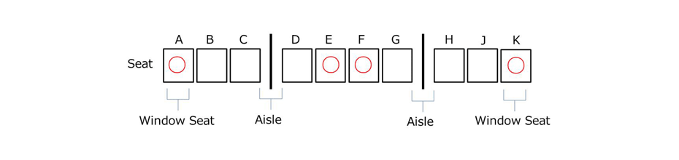

- Using in flight:
- Using PIB must enable the proper use of the aircraft seat belt.
- PIB cannot be used during taxiing, take-off, and landing.
- PIB must not damage the aircraft seat if they need to be attached to any part of the seat.
- In order to ensure a safe and comfortable flight, the cabin attendants will check on seatbelt usage and that other passengers are not being inconvenienced.
- Also during cruise, you may be asked to refrain from usage depending on the circumstances.
- Using the PIB, the resting position must be along the longitudinal axis of the airplane, the head points to the aircraft tail.

