Cargo identification label:

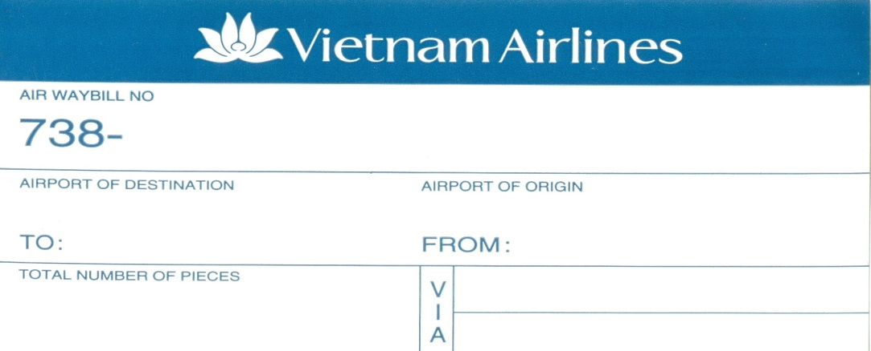

Dangerous goods labels:



[](http://www.manylabels.com/scripts/prodView.asp?idproduct=585)[](http://www.manylabels.com/scripts/prodView.asp?idproduct=587)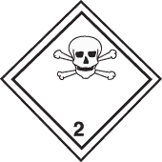

[[](http://www.manylabels.com/scripts/prodView.asp?idproduct=593)](http://www.manylabels.com/scripts/prodView.asp?idproduct=593)

[](http://www.manylabels.com/scripts/prodView.asp?idproduct=591)[](http://www.manylabels.com/scripts/prodView.asp?idproduct=595)[](http://www.manylabels.com/scripts/prodView.asp?idproduct=597)

[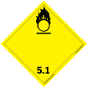](http://www.manylabels.com/scripts/prodView.asp?idproduct=599)[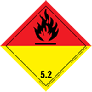](http://www.manylabels.com/scripts/prodView.asp?idproduct=1254)

[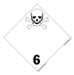](http://www.manylabels.com/scripts/prodView.asp?idproduct=603)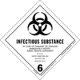

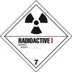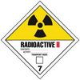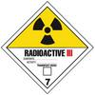

[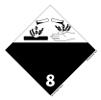](http://www.manylabels.com/scripts/prodView.asp?idproduct=608)

[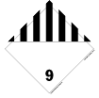](http://www.manylabels.com/scripts/prodView.asp?idproduct=609)

Handling labels:

 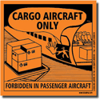  

 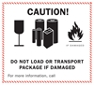 

[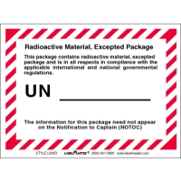](http://www.labelmaster.com/Shop/image.aspx?i=L335R&w=400)