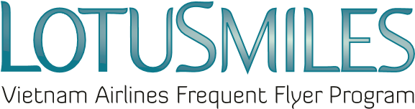

AUTHORIZATION PAPER

I am…………………………..…………………….…Lotusmiles membership number…………………
hereby authorized:
- Mr/Mrs/Ms:………………………………………………………………………………………………
- Identity card/passport number:………………………………………………………………………..
- Phone number:…………………………………………………………………………………………
- Email:……………………………………………………………………………………………………
to act on my behalf in all possible manners to my Lotusmiles account, including:
☐ Request to be provided my account activities
☐ Redeem my miles, request to change my rewards
☐ Claim my missing miles
☐ Buy/transfer/convert/extend/reinstate miles
This authorization is valid from:……………………….………..to:………………………………………

Required documents when authorizing:  - Authorizer ‘s Lotusmiles membership card image  - Identity card or passport images of both Authorizer and Authorized person.  - In case the authorized person request the award at Vietnam Airlines branch offices, he/she is required to present the original copies of all documents above. | ☒ I agree with the Terms & Conditions of Lotusmiles and the Privacy Policy of Vietnam Airlines  Member’s signature  Date: / /
=========================================================================
Note: Each member can assign to only 01 person in a certain period.
The authorized person will perform the transactions listed above on behalf of the member. Other information will be contacted and notified directly by the Lotusmiles program to the member.

